**Installing TomEE using the drop-in .war approach**

If you prefer, TomEE can be setup by deploying a .war file into an existing Tomcat 7.x installation, as opposed to using the all-in-one bundle. This guide provides a set of step-by-step instructions to this approach. Please note that TomEE 1.7.x does not recommend Tomcat versions less than 7.0.54. Tomcat 8 is not currently supported in the released version, but you can check out the developer branch to see progress [here](http://tomee.apache.org/dev/source-code.html).

* Download the Apache Tomcat 7.0.55 server. <http://tomcat.apache.org/download-70.cgi>
* Unzip the Tomcat distribution file.
* Update $CATALINA_HOME/conf/tomcat-users.xml to add a tomee user to allow access to the installer page.
* <!-- Activate/create these lines to get access to TomEE GUI -->
* <role rolename="tomee-admin" />

<user username="tomee" password="tomee" roles="tomee-admin" />

* Download the .war file you wish to use - either the tomee-webapp-1.7.1.war (for the webprofile installation) or tomee-webapp-plus-1.7.1.war (for the plus version).
* Copy and rename the .war file to $CATALINA_HOME/webapps/tomee.war (the .war filename is important).
* Start Tomcat.
* Go to the TomEE installer webapp (<http://localhost:8080/tomee/>) and login with the user you added to tomcat-users.xml.
* Verify the values and click "Confirm".

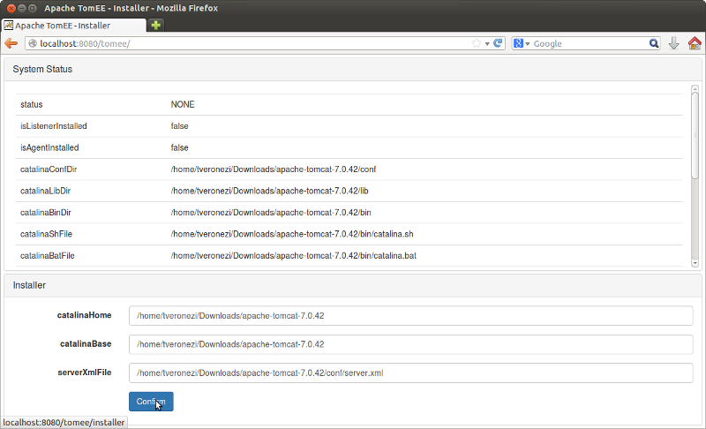

* Restart Tomcat.
* Your TomEE installation is now complete!

**Configuraing TomEE to use External ActiveMQ**

1. Add the ActiveMQ libraries from the OpenEJB standalone project to the [TomEE]/lib directory. These libraries are also included in the subdirectory, **activemq_lib_list**. Minimally, the following jars are needed:
   * *activemq-broker-5.10.2.jar*
   * *activemq-client-5.10.2.jar*
   * *activemq-ra-5.10.2.jar*
   * *geronimo-connector-3.1.1.jar*
   * *jconn3.jar*
2. Modify [TomEE]\conf\openejb.xml by adding the following database resources. An example openejb.xml can be found in the root directory. For some reason, there exist a problem when configuring datasources in Tomcat’s context.xml.

*<Resource id = "jdbc/accounting" type="DataSource">*

*JdbcDriver com.sybase.jdbc3.jdbc.SybDriver*

*JdbcUrl jdbc:sybase:Tds:localhost:2638?ServiceName=accounting*

*UserName dba*

*Password sql*

*JtaManaged true*

*</Resource>*

*<Resource id = "jdbc/projecttracker" type="DataSource">*

*JdbcDriver com.sybase.jdbc3.jdbc.SybDriver*

*JdbcUrl jdbc:sybase:Tds:localhost:2638?ServiceName=projecttracker*

*UserName dba*

*Password sql*

*JtaManaged true*

*</Resource>*

*<Resource id = "jdbc/authentication" type="DataSource">*

*JdbcDriver com.sybase.jdbc3.jdbc.SybDriver*

*JdbcUrl jdbc:sybase:Tds:localhost:2638?ServiceName=authentication*

*UserName dba*

*Password sql*

*JtaManaged true*

*</Resource>*

*<Resource id = "jdbc/addressbook" type="DataSource">*

*JdbcDriver com.sybase.jdbc3.jdbc.SybDriver*

*JdbcUrl jdbc:sybase:Tds:localhost:2638?ServiceName=contacts*

*UserName dba*

*Password sql*

*JtaManaged true*

*</Resource>*

*<Resource id = "jdbc/mime" type="DataSource">*

*JdbcDriver com.sybase.jdbc3.jdbc.SybDriver*

*JdbcUrl jdbc:sybase:Tds:localhost:2638?ServiceName=mime*

*UserName dba*

*Password sql*

*JtaManaged true*

*</Resource>*

1. Modify [TomEE]\conf\openejb.xml by adding the following ActiveMQ configuration:

*<Resource id="MyJmsResourceAdapter" type="ActiveMQResourceAdapter">*

*# Do not start the embedded ActiveMQ broker*

*BrokerXmlConfig =*

*ServerUrl = tcp://localhost:61616*

*</Resource>*

*<Resource id="MyJmsConnectionFactory" type="javax.jms.ConnectionFactory">*

*ResourceAdapter = MyJmsResourceAdapter*

*</Resource>*

*<Container id="MyJmsMdbContainer" ctype="MESSAGE">*

*ResourceAdapter = MyJmsResourceAdapter*

*</Container>*

1. Add jconn3.jar to [TomEE]\lib.
2. Create **\apps** directory under [TomEE]. This is where the EJB deployment jars will be placed.
3. Restart Tomcat.